LAB 2 REPORT

1. Aim and Assumptions
This lab describes agents using PEAS, classifies their environments, and tests a classroom agent that remembers its previous mode. Temperature is in °C; occupied is True or False. ECO, COOL, WARM and IDLE are simulated labels only. The code does not control real equipment.

2. PEAS Specifications

A. Delivery Robot
Performance: Deliver the correct package on time; avoid collisions and protect people and packages.
Environment: Campus or streets, corridors, doors, people, vehicles, weather and delivery locations.
Actuators: Drive motors/wheels; steering and braking; package lock or delivery indicator.
Sensors: Camera/depth sensor; GPS or indoor location system; obstacle/proximity sensors.
Trade-off and assumptions: A faster route can increase collision risk, so safety must take priority over speed. Assume the robot can use its map, location and obstacle sensors, but cannot know every person's intentions or future traffic.

B. LLM-Based Student-Support Agent
Performance: Give correct, understandable help; protect student privacy; avoid unsupported answers.
Environment: Student questions, course materials, learning platform and academic rules.
Actuators: Display a text response; ask a follow-up question; link to an approved learning resource.
Sensors: Typed student message; course files supplied by the student; available conversation context.
Trade-off and assumptions: A quick answer is not useful if it is incorrect, so reliability matters more than reply speed. Assume the agent can read the student's message and supplied course files. It cannot access private records, grades or external tools unless explicitly connected and authorised.

3. Environment Classification
Delivery robot: Partially observable and stochastic in the real world. Sensors may miss hidden obstacles or people's intentions. People, weather and traffic can make action outcomes uncertain. A simplified simulator with complete fixed inputs and fixed rules may be fully observable and deterministic.
Student-support agent: Partially observable and stochastic in real use. The agent cannot directly know a student's full understanding or unstated context. The same prompt may lead to different responses. A fixed scripted test may be deterministic within that test.
These classifications depend on the chosen model boundary and assumptions. PEAS describes the task environment; it does not itself implement a rational policy.

4. Classroom Agent: Reflex vs Stateful
The reflex agent chooses a mode from the current percept only. The stateful agent also stores the previous target mode and sends a command only if the target changes. An empty room has priority over temperature.
• If the room is empty: ECO.
• If occupied and temperature is above 26°C: COOL.
• If occupied and temperature is below 20°C: WARM.
• If occupied and temperature is 20°C to 26°C inclusive: IDLE.
At exactly 20°C and 26°C, an occupied room selects IDLE because the comparisons are < 20 and > 26. The stateful agent is not learning from data; it only remembers the previous mode.

5. Test Results and Mode-Transition Trace
The actual test trace is:
Step 1 — Previous: None; Percept: (True, 28); Target: COOL; Command: SEND.
Step 2 — Previous: COOL; Percept: (True, 28); Target: COOL; Command: NO.
Step 3 — Previous: COOL; Percept: (True, 20); Target: IDLE; Command: SEND.
Step 4 — Previous: IDLE; Percept: (True, 26); Target: IDLE; Command: NO.
Step 5 — Previous: IDLE; Percept: (True, 18); Target: WARM; Command: SEND.
Step 6 — Previous: WARM; Percept: (False, 24); Target: ECO; Command: SEND.
Step 7 — Previous: ECO; Percept: (False, 24); Target: ECO; Command: NO.
The basic reflex trace produced COOL, COOL, WARM, IDLE, IDLE and ECO. It repeats COOL for repeated inputs. The stateful agent avoids sending the same command twice in a row.

6. Edge Case, Limitation and Improvement
Tested edge cases: an occupied room at 20°C and 26°C selects IDLE; repeating (False, 24) selects ECO but sends a command only the first time. A limitation is that readings fluctuating around 26°C could alternate between COOL and IDLE. Remembering the previous mode alone does not prevent this. One improvement is hysteresis (separate switch-on and switch-off thresholds) plus sensor validation; this would need further testing.

7. Reflection and Responsible Practice
What I learned: PEAS separates an agent's goals, environment, actions and inputs. Internal state can help an agent avoid repeated commands.
Real-world application: This design could support classroom energy control, but reliable sensors and safety checks are needed before controlling equipment.
What surprised me: The reflex agent returns COOL twice for repeated high-temperature inputs. The stateful agent sends a command only when the target changes.
Responsible practice: Protect student information, explain uncertainty, cite sources and keep a human involved in important educational decisions. This classroom code is a simulation only.

8. How to Run and Submit
Keep check.py, model.py and percepts.py in the same folder. In the VS Code terminal, run:
python percepts.py
python check.py
Include the source files, input data if used, README.md with setup/run commands, captured outputs or trace files, and this Lab2_Report.docx in the Lab 2 folder. Upload to the course GitHub repository and submit its URL and final commit identifier through the course submission channel. Do not upload credentials, private information or virtual environments. Screenshots do not replace source code and the report.

9. Source
Course source: AI_Lab_Manual_CS4944_lab-2.pdf (PEAS, environment taxonomy, classroom trace, model limitations and submission guidelines). The traces in this report are based on the student's supplied program-output screenshots.

Appendix: Captured Program Outputs
A. Basic classroom agent output (percepts.py)
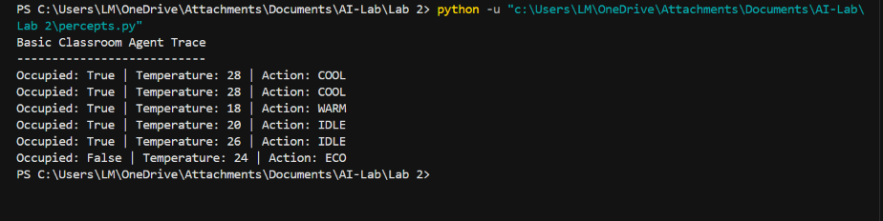
B. Stateful agent test output (check.py)
